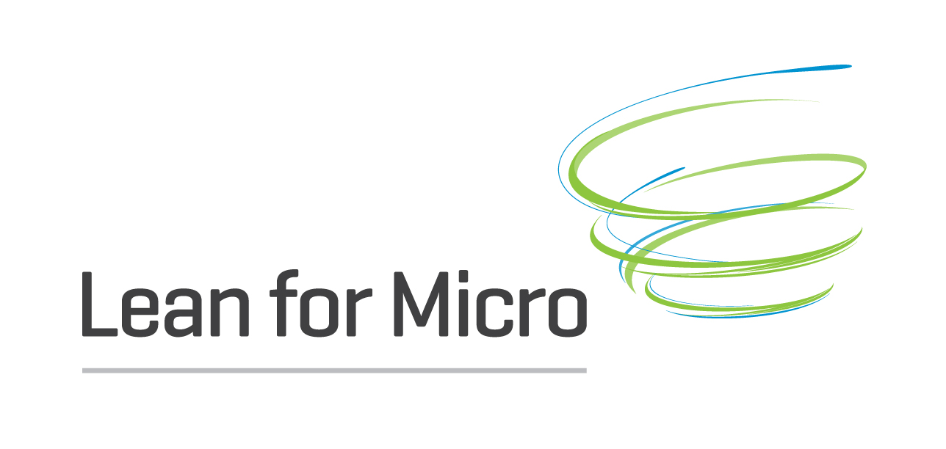

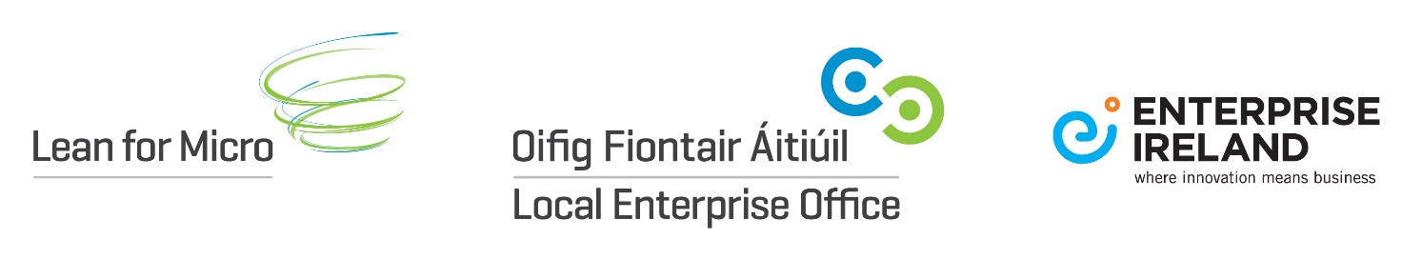

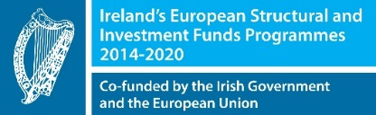

Lean thinking is about creating the most value for the customer at very little cost, achievable through reducing resources, time, energy and cost.
Lean tools and techniques are helping companies across the globe to address competitiveness issues within their businesses, building the capability of their people to identify issues and improve their operations.
Lean for Micro is designed to encourage clients to adopt Lean business principles in their organisations to increase competitiveness.
The key to becoming and remaining competitive is Lean: the relentless pursuit of value to the customer.
What is Lean?
Lean is about being effective and efficient - doing things quicker, better, cheaper…together. Lean strives to stamp out waste and to continually improve.
Lean requires that individuals, teams and the entire organisation remain continuously focussed on the customer, adopting a practical approach to increasing value to the customer by the relentless elimination of every form of unnecessary waste.
Lean is a way of thinking and acting that enables people to drive the organisation forward. It increases capability and capacity, and is the catalyst for innovation.
Lean helps ensure flexibility, responsiveness, efficiency, innovation and by continuously listening to the customer allows companies to compete and win on merit.
Why Lean? Benefits
All businesses must continually evolve and look for ways to improve. This is particularly relevant for small businesses which are looking to create a competitive advantage. Lean thinking and practice should be paramount for any small business to ensure they are using their resources to help maximise their outputs. This creates benefits for the whole business, from the owners to employees and customers. The Lean for Micro programme looks at how to create the best value for the customer by driving continuous improvements to utilise time, effort and resources giving greater returns to the business, improving productivity and competitiveness. (https://www.localenterprise.ie/Documents-and-Publications/LEAN/
The LEO Lean for Micro business programme helps to:
- Identify issues and potential improvement areas
- Provide support to implement
- Achieve savings and improvements in capability and capacity to deliver

Completion
The programme involves a short in-company assignment by an external ‘Lean’ consultant selected by you from a panel, who will introduce Lean principles and complete a specific cost reduction project.
The programme will commence with a diagnosis of current practice and performance. Key performance indicators will be established to achieve targeted business improvement measures based on a set of Lean tools and methodologies tailored to suit each client’s situation.
The programme will be available to LEO clients. Lean for Micro is available to Measure 1 LEO eligible companies who employ up to 10 employees in eligible LEO sectors who have the potential to export / internationally trade. LeanStart is available to all businesses across sectors in Kilkenny.
Participating clients will be selected subject to eligibility as determined by LEOs and depending on the client’s existing capability in using Lean business principles, the current size, and their particular business development needs.
The cost of the pilot programme to the company will be €1,000 with LEO support of an additional €4,500.
There are two types of Lean Support available;
1. LeanStart – learn the basics, more focused for smaller companies with targeted Lean needs and wanting to adapt their current business into the Lean Processes. The Half Lean Programme be typically carried out over 2 to 4 weeks. Companies will be eligible to receive support for a maximum of 3 consultancy days to a limit of €2,700.
2. LeanPlus – focused around performance improvement, which will be typically carried out over 6 to 8 weeks. Companies will be eligible to receive support for a maximum of 5.5 consultancy days to a limit of €5,500
Companies can apply for grant support towards the cost of hiring a Lean consultant/trainer to undertake a short in-company assignment. Details of available consultants can be sought from https://www.leanbusinessireland.ie/lean-project-database/ and by completing the Lean for Mirco Programme businesses can expect to
- introduce Lean principles and Agile processes
- achieve immediate cost reduction targets
- lay a foundation for future Lean or productivity improvement projects
- incorporate First Steps to Green Competitiveness Guidebook

How to Apply
All applications for Lean for Micro should be discussed with your Local Enterprise Office. Please contact Aileen McGrath on 056 7794703 or email aileen.mcgrath@leo.kilkennycoco.ie
An application form is required to be completed, you must identify your LEAN Consultant and send it into us.
Businesses who can demonstrate a capability for a lean project will be required to complete an application form for Lean for Micro and must identify their own Lean Consultant. Details of available Consultants can be sought from https://www.leanbusinessireland.ie/lean-project-database/ and by accessing the LEO Kilkenny list of LEAN mentors.
Further Information
Local Enterprise Office
http://www.localenterprise.ie
Enterprise Ireland
Becoming LEAN Project Database and Case Studies
https://www.leanbusinessireland.ie/lean-project-database/
What is Lean
https://planet-lean.com/

